



DEPARTMENT OF COMPUTER SCIENCE

THEORY OF COMPUTATION
LAB 1
STRING MATCHING & COMPARISION

Submitted by: |  | Submitted to: | Signature:
Prasoon Raj Shakya  Roll No.: 024BSCIT028  4th Sem - Section B |  | Mr. Ganesh Dhami  Department of Computer Science  St. Xavier’s College

LAB 1.1: Program for Checking Valid Strings over a Given Alphabet Set

Background and Requirements
In formal language theory, an alphabet (Σ) is a finite set of symbols from which strings are formed. A string is considered valid over an alphabet if every character in the string belongs to that alphabet.
For example, if: Σ = {a, b}
Then:
- Valid strings: aaa, ababab, bbb
- Invalid strings: abacx, x, abcd, "" (empty string)
This concept is fundamental in Automata theory, Compiler design (lexical analysis) and Pattern recognition systems.
The task is to accept a symbol set (alphabet) and a single input string and determine whether the string is fully composed of symbols from the given alphabet.

Python programming language interpreter, Visual Studio Code (VS Code), Python Extension, and Environment Path Setup are required.

Source Code
import os
os.system("cls")

symbol_set = input("Enter symbol set: ")
string = input("Enter string: ")

for ch in string:
found = False
for sym in symbol_set:
if ch == sym:
found = True
break
if not found:
print("Invalid String")
exit()
print("Valid String")

Output/Observations
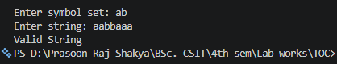
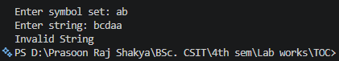

Conclusion
The Python program successfully verifies whether a given string belongs to a specified alphabet set by ensuring all characters are part of the defined symbol set. This demonstrates the fundamental principle of string acceptance in formal languages and provides a basic implementation of deterministic finite automata behavior in software form.

LAB 1.2: Program checks if a string is prefix of another string

Background and Requirements
In formal language theory, a prefix of a string is a substring that appears at the beginning of another string. A prefix is called a proper prefix if it is shorter than the original string, and an improper prefix if it is identical to the original string.
For example, if: String = "abcde"
Then:
- Proper prefixes: "a", "ab", "abc", "abcd"
- Improper prefix: "abcde"
- Not prefixes: "bcd", "cde", "abd"
This concept is used in string processing, pattern matching, lexical analysis, and automata theory.
The task is to accept two strings, s1 and s2, and determine whether s2 is a proper prefix, improper prefix, or not a prefix of s1.

Source Code
def length(str):
i=0
for ch in str:
i+=1
return i

s1 = input("Enter a string: ")
s2 = input("Enter another string: ")
i=0
if s1 == s2:
print("improper prefix")
elif length(s2)>length(s1):
print("not a prefix")
else:
prefix = True
for i in range(length(s2)):
if s1[i] != s2[i]:
prefix = False
break
if prefix:
print("Proper Prefix")
else:
print("Not a Prefix")

Output/Observations
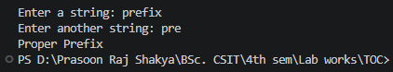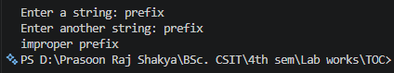
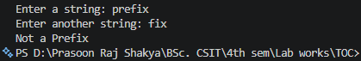

Conclusion
This program successfully determines whether one string is a proper prefix, improper prefix, or not a prefix of another string. It uses a user-defined function to find string lengths and performs character-by-character comparison to verify the prefix relationship. Through this lab, the concepts of prefix checking were understood and implemented effectively in Python.

LAB 1.3: Program checks if a string is suffix of another string

Background and Requirements
In formal language theory, a suffix of a string is a substring that appears at the end of another string. A suffix is called a proper suffix if it is shorter than the original string, and an improper suffix if it is identical to the original string.
For example, if: String = "abcde"
Then:
- Proper suffixes: "e", "de", "cde", "bcde"
- Improper suffix: "abcde"
- Not suffixes: "abc", "bcd", "ace"
This concept is used in string processing, pattern matching, lexical analysis, and automata theory.
The task is to accept two strings, s1 and s2, and determine whether s2 is a proper suffix, improper suffix, or not a suffix of s1.

Source Code
def length(str):
i = 0
for ch in str:
i += 1
return i

s1 = input("Enter a string: ")
s2 = input("Enter another string: ")

if s1 == s2:
print("improper suffix")
elif length(s2) > length(s1):
print("Not a suffix")
else:
suffix = True
for i in range(1, length(s2)+1):
if s1[- i] != s2[-i]:
suffix = False
break
if suffix:
print("Proper Suffix")
else:
print("Not a Suffix")
Output/Observations
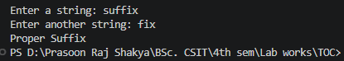
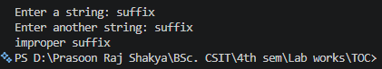
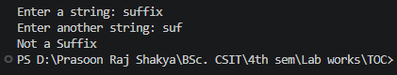

Conclusion
This program successfully determines whether one string is a proper suffix, improper suffix, or not a suffix of another string. It uses a user-defined function to find string lengths and performs character-by-character comparison from the end of the strings to verify the suffix relationship. Through this lab, the concepts of suffix checking were understood and implemented effectively in Python.

Lab 1.4: Program checks if a string is substring of another string

Background and Requirements
In formal language theory, a substring is a sequence of characters that occurs consecutively within another string. A substring may appear at the beginning, middle, or end of the original string. Every string is considered a substring of itself.
For example, if: String = "abcde"
Then:
- Substrings: "ab", "bcd", "cde", "abcde", "cd"
- Not substrings: "ace", "aed", "bdc"
Substring checking is widely used in string processing, text searching, pattern matching, lexical analysis, and automata theory.
The task is to accept two strings, s1 and s2, and determine whether s2 is a substring of s1 by comparing characters at consecutive positions.

Source Code
def length(s):
count = 0
for ch in s:
count += 1
return count

s1 = input("Enter a string: ")
s2 = input("Enter another string: ")
substring = False
for i in range(length(s1) - length(s2) + 1):
match = True
for j in range(length(s2)):
if s1[i + j] != s2[j]:
match = False
break
if match:
substring = True
break
if substring:
print("Substring")
else:
print("Not a Substring")
Output/Observations
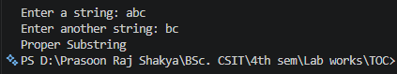
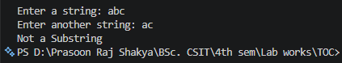
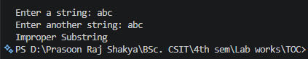

Conclusion
This program successfully determines whether one string is a substring of another string. It uses a user-defined function to find string lengths and performs character-by-character comparison at different positions within the main string to verify the substring relationship. Through this lab, the concepts of substring searching, nested loops, and string comparison were understood and implemented effectively in Python.

